

* 3rd Deliverable (ERD Diagram)
* Group Members:
  + Abdullah Ahmad Arslan (FA22-BCS-042), CGPA: 3.75, Mail: [FA22-BCS-042@cuilahore.edu.pk,](mailto:FA22-BCS-042@cuilahore.edu.pk) Phone: 03334578883
  + Muhammad Awais (FA22-BCS-185), CGPA: 3.41, Mail: [FA22-BCS-185@cuilahore.edu.pk,](mailto:FA22-BCS-185@cuilahore.edu.pk) Phone: 03320144667
* **Subject:** Database Systems
* **Professor Name:** Dr. Abid Sohail
* **Relational Schema:**

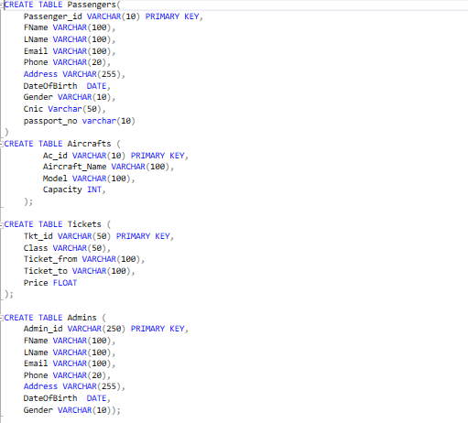

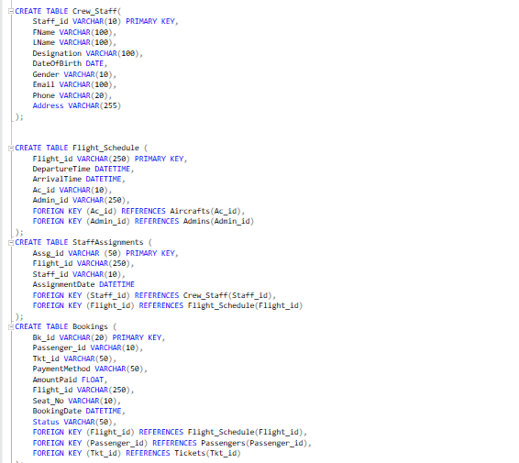

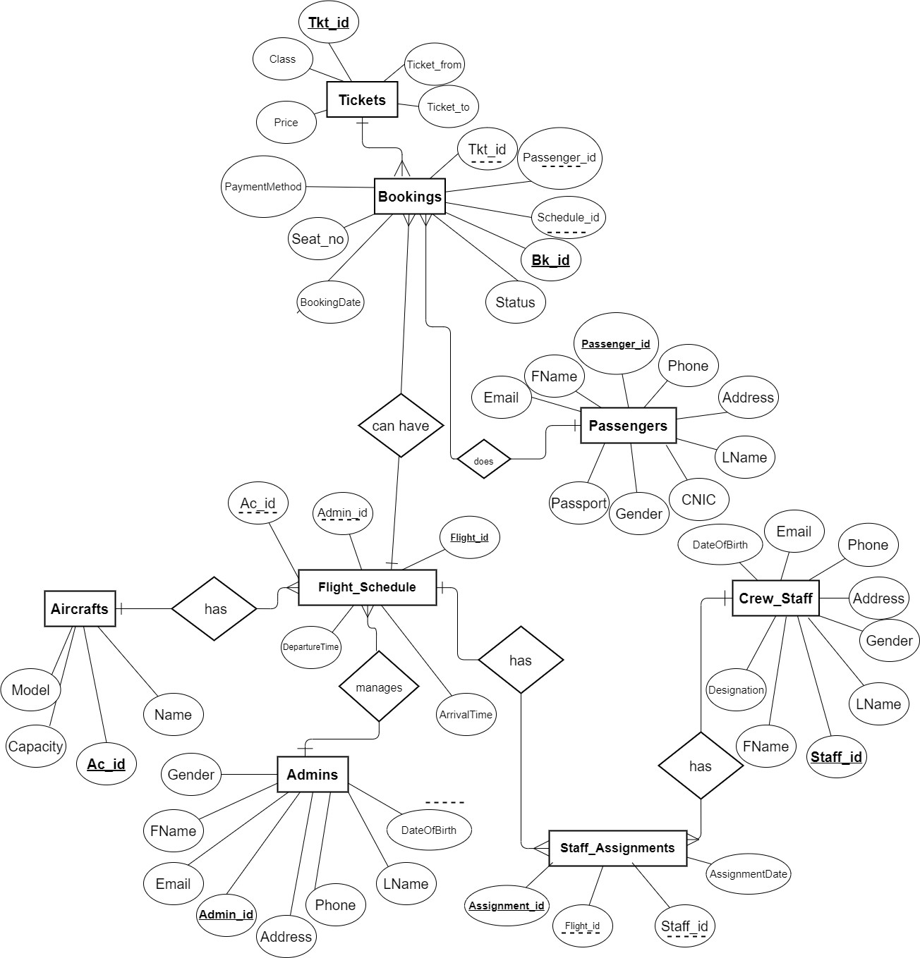

* **Data Population:**

